
Content Calendar for Vet Practices
ZA-NOV-230100010
POST |  | IMAGE
Post 1  Do you remember the term “Kennel Cough” every time you took your dog to the kennel before a holiday?  It is now referred to as canine infectious respiratory disease complex (CIRD) as kennel cough can be misleading, because only 20 % of CIRD cases are associated with boarding and kennelling.¹ Canine cough more accurately reflects the risk of CIRD, which can be spread anywhere dogs socialise.  Call us on  (____Practice Tel Number _____)  today, to make an appointment and ask us about the  intra-nasal Nobivac® KC vaccine or the NEW injectable Nobivac® Respira Bb to protect your dog against Canine Cough.  References: 1. Data on file. Vet and Pet Owner CIRD Quantitative Market Research Surveys; 2022 |  | Post 1:  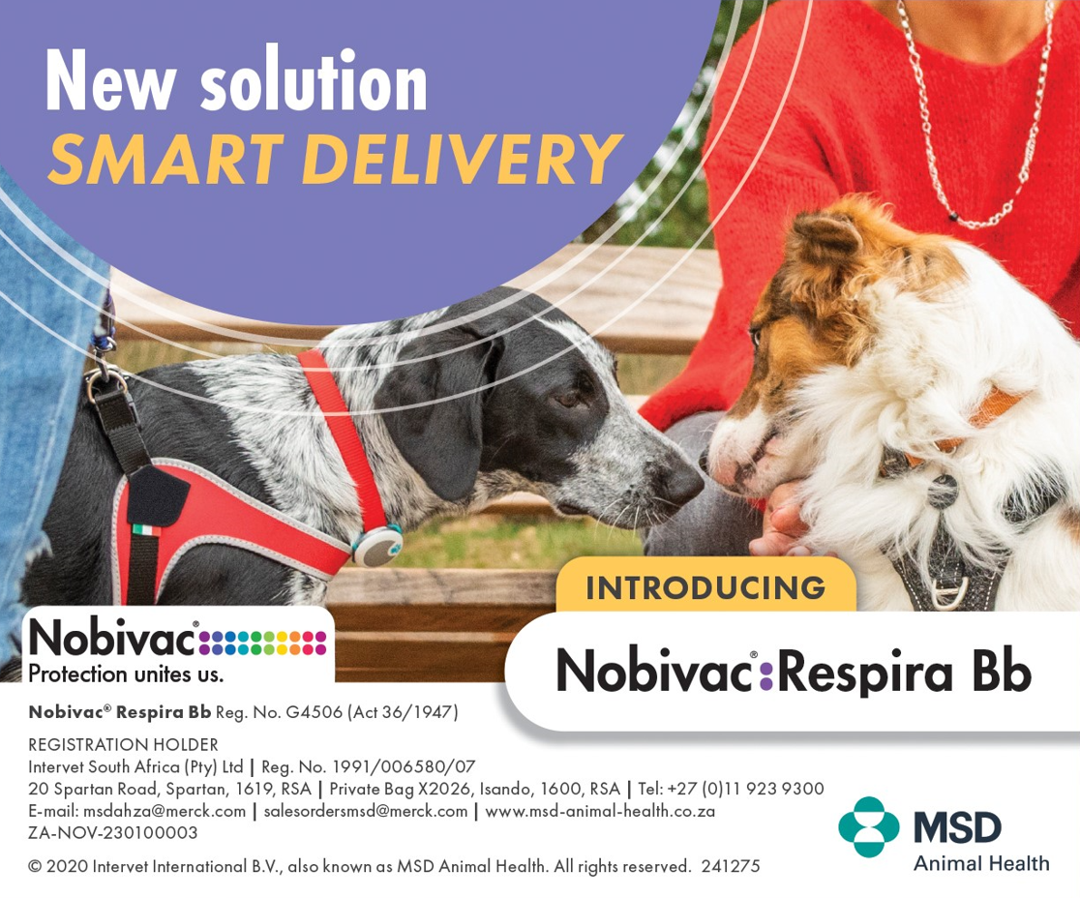
Post 2:  Your dog can catch Canine Cough on walks, at the park, day care, kennel facilities or anywhere they interact with other dogs.  Call us on  (____Practice Tel Number _____)  today, to make an appointment and ask us about the  intra-nasal Nobivac® KC vaccine or the NEW injectable Nobivac® Respira Bb to protect your dog against Canine Cough. |  | Post 2:  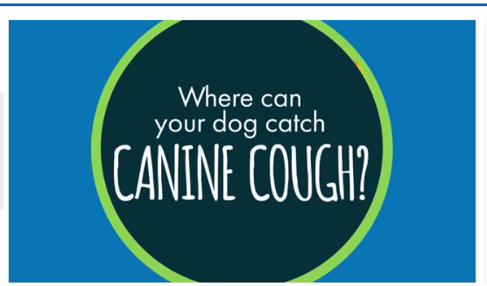
POST 3:  Do you take your dogs to the park or beach for walks?  Canine cough poses a threat to any social dog. Our research showed the majority of cases were from social settings, such as walking in parks.¹  Call us on  (____Practice Tel Number _____)  today, to make an appointment and ask us about the  intra-nasal Nobivac® KC vaccine or the NEW injectable Nobivac® Respira Bb to protect your dog against Canine Cough.  References: 1. Data on file. Vet and Pet Owner CIRD Quantitative Market Research Surveys; 2022 |  | Post 3:  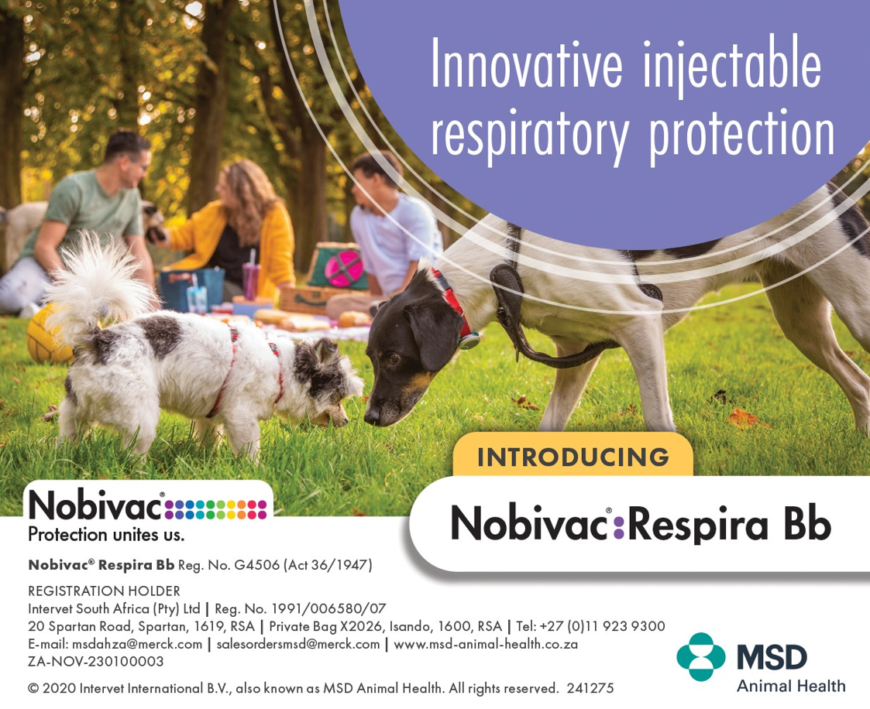
POST 4:  Canine cough poses a threat to all social dogs and can be distressing to your pets and you as their owner. In fact, 96 % of pet owners report feeling stress associated with canine infectious respiratory disease (CIRD) infection.¹  It just takes 2 Nobivac® Respira Bb inoculations initially 4 weeks apart, and then once a year, or 1 Nobivac® KC intra-nasal vaccine yearly to keep your dog protected against canine cough.  Call us on  (____Practice Tel Number _____)  today, to make an appointment and ask us about the  intra-nasal Nobivac® KC vaccine or the NEW injectable Nobivac® Respira Bb to protect your dog against Canine Cough.  References: 1. Data on file. Vet and Pet Owner CIRD Quantitative Market Research Surveys; 2022 |  | Post 4:  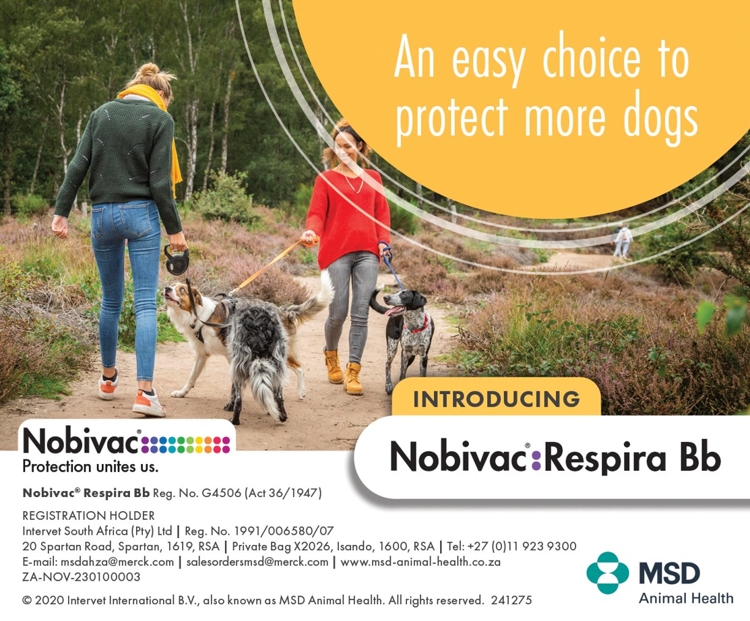
Post 5:  Do you take your dogs to doggy friendly restaurants or family and friends’ homes?  Canine cough poses a threat to any social dog. Our research showed the majority of cases were from social settings.¹  Call us on  (____Practice Tel Number _____)  today, to make an appointment and ask us about the  intra-nasal Nobivac® KC vaccine or the NEW injectable Nobivac® Respira Bb to protect your dog against Canine Cough.  References: 1. Data on file. Vet and Pet Owner CIRD Quantitative Market Research Surveys; 2022 |  | Post 5:  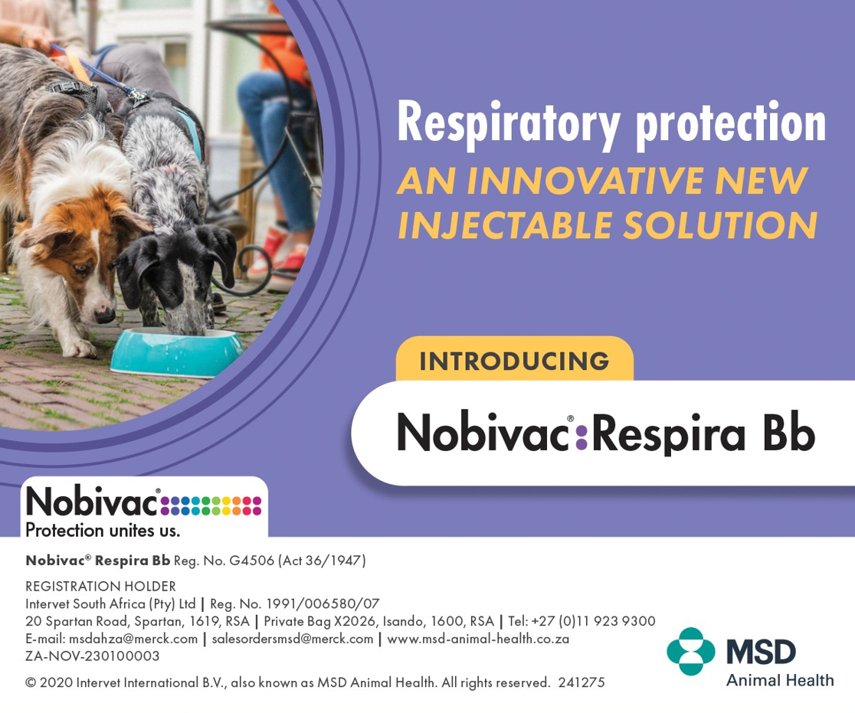
Post 6  Did you know that nearly 40% of canine infectious respiratory disease (CIRD) cases were associated with routine social activities like playing together in parks, greeting other dogs and taking walks?¹  Routine social activities increase the risk of Canine Cough.  Call us on  (____Practice Tel Number ___)  today, to make an appointment and ask us about the  intra-nasal Nobivac® KC vaccine or the NEW injectable Nobivac® Respira Bb to protect your dog against Canine Cough.  References: 1. Data on file. Vet and Pet Owner CIRD Quantitative Market Research Surveys; 2022 | Post 6:  