ZA-NOV-220700006
September 2022 Rabies Month
September is Rabies Awareness Month! Please help raise awareness and drive vaccination at your practice. Below find social media content which can be shared on your social media pages, the images can be downloaded from https://www.msd-animal-health.co.za/afya-world-rabies-2022/
Contact your MSD Animal Health representative should you need more information on Nobivac® Rabies, your support of Nobivac® helps us in our mission to eradicate dog-mediated rabies by 2030.
With every Nobivac® Rabies vaccine you use in your practice, you help MSD to continue donating vaccines to where they are needed, with 5 million doses having been donated so far.
Visit www.afya.org for more info on how MSD Animal Health is helping to fight Rabies.
The following are some suggested images and copy for your social media posts.
You are welcome to add the following tags to your post; e.g.
#360ChallengeVet2022 #WorldRabiesDay and #EndRabiesNow #Dogs #Cats

POST | IMAGE
POST 1:  Zero by 30 is a global goal set by the World Health Organization (WHO) dedicated to eliminating deaths in people from canine-mediated rabies by the year 2030.  A thank you to the vet community who work tirelessly to educate pet owners about vaccination.  Check out http://ow.ly/VCmu50FYE4m to see how MSD Animal Health are helping in the fight against rabies.  #EndRabiesNow  #Nobivac #BravectoSA #WorldRabiesDay | Post 1.  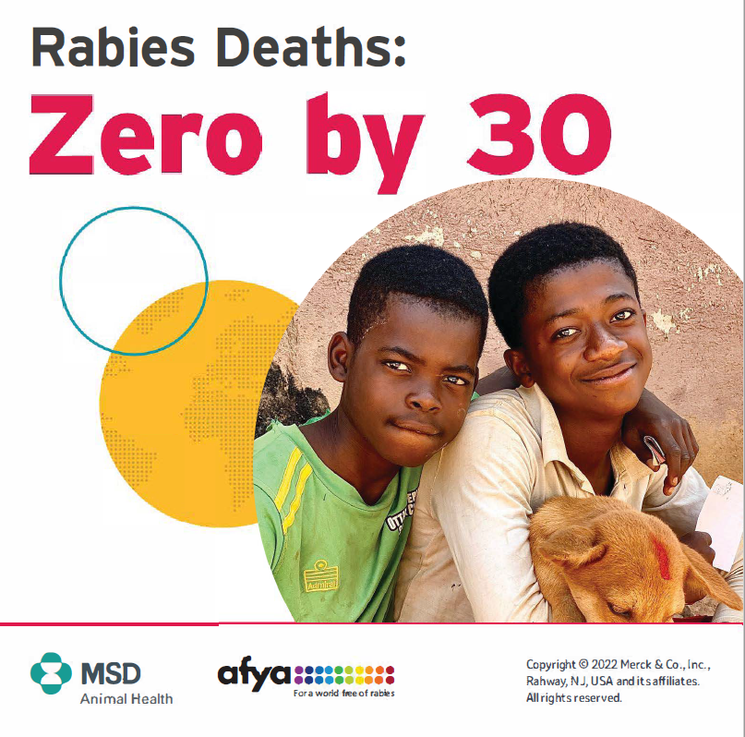
POST 2:  Rabies kills an estimated 59,000 people each year, with almost half of them being children under 15 years of age. This is a tragedy because rabies is 100 % vaccine-preventable and one of the most cost-effective ways of achieving this is by routine vaccination of dogs.  #EndRabiesNow  #Nobivac #BravectoSA #WorldRabiesDay  Contact us today to have your pet vaccinated against Rabies. | Post 2.  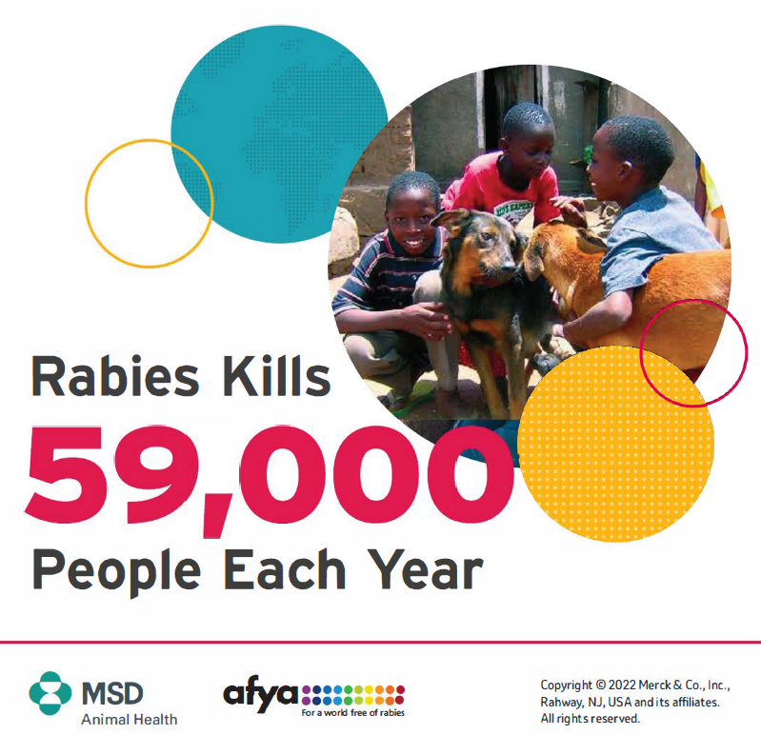
Post 3:  By vaccinating dogs, we prevent the spread of rabies to people. Once 70 % of dog populations are protected through vaccination, we stop human deaths, and awareness is key. So, spread the word.  #Nobivac #BravectoSA  #WorldRabiesDay #EndRabiesNow  Is your pet protected? Contact us today for an appointment. | Post 3  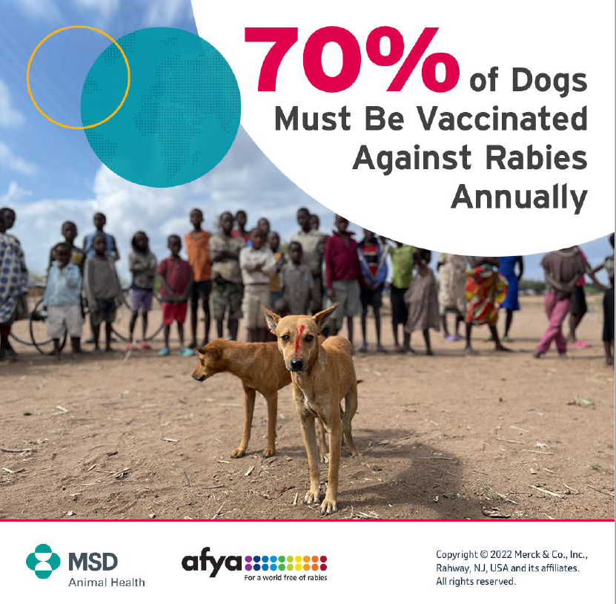
Post 4:  RABIES WEEK IS HERE  Global Rabies Week runs from 27 September to 1 October. Be sure to get your fur kids vaccinated.  Remember, rabies is 100 % preventable if your pet is vaccinated.  #EndRabiesNow  #Nobivac #BravectoSA #WorldRabiesDay  Contact us to make an appointment to get your pet vaccinated. | Post 4  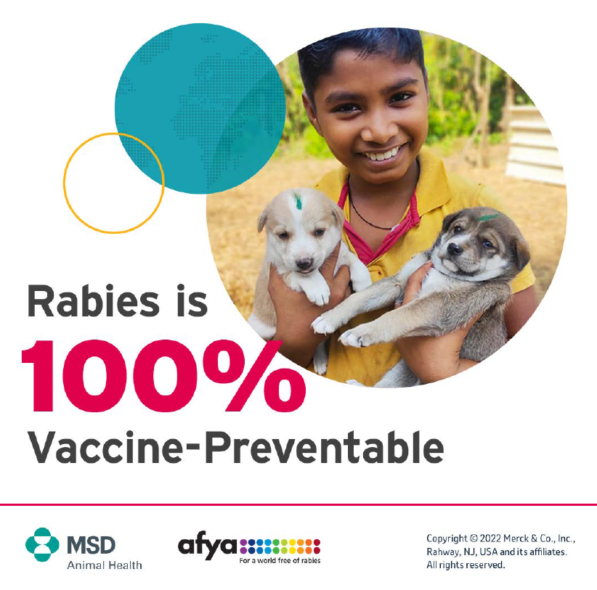
Post 5: 28th September  VACCINATE TO ELIMINATE  World Rabies Day on 28th September, was created to spread awareness of the deadly disease which affects humans and animals alike.  Rabies is a virus that is usually contracted through a bite from an infected animal, often a dog. By the time the symptoms appear, it is often too late to save the patient.  You can stop the Rabies cycle by ensuring your pet’s vaccinations are up to date. A simple booster keeps your pets protected from this awful disease.  #Nobivac #BravectoSA #WorldRabiesDay  #EndRabiesNow | Post 5:  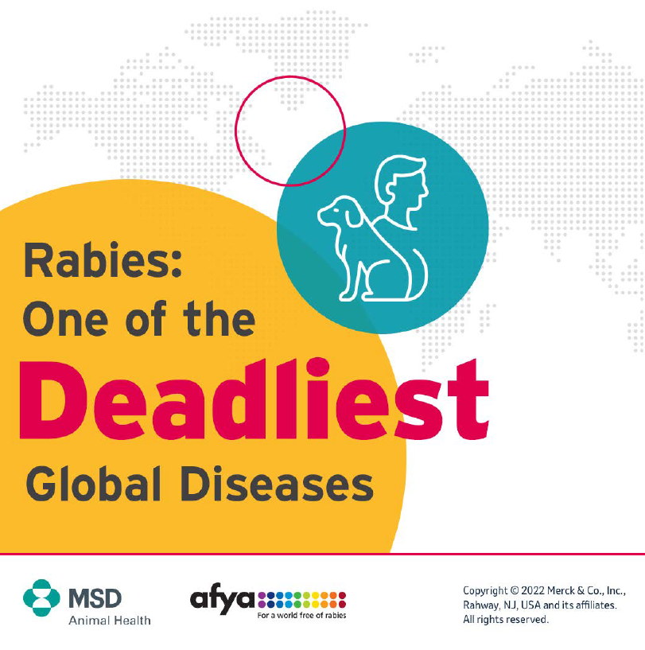
Post 6:  Did you know: 5 million doses of Nobivac® Rabies vaccine have been donated globally to support the United Against Rabies collaboration “Zero by 30” rabies elimination goal.  #EndRabiesNow  #Nobivac #BravectoSA #WorldRabiesDay  Have your pet vaccinated at our practice with Nobivac® Rabies and help donate lifesaving vaccines to the regions that need it. | Post 6:  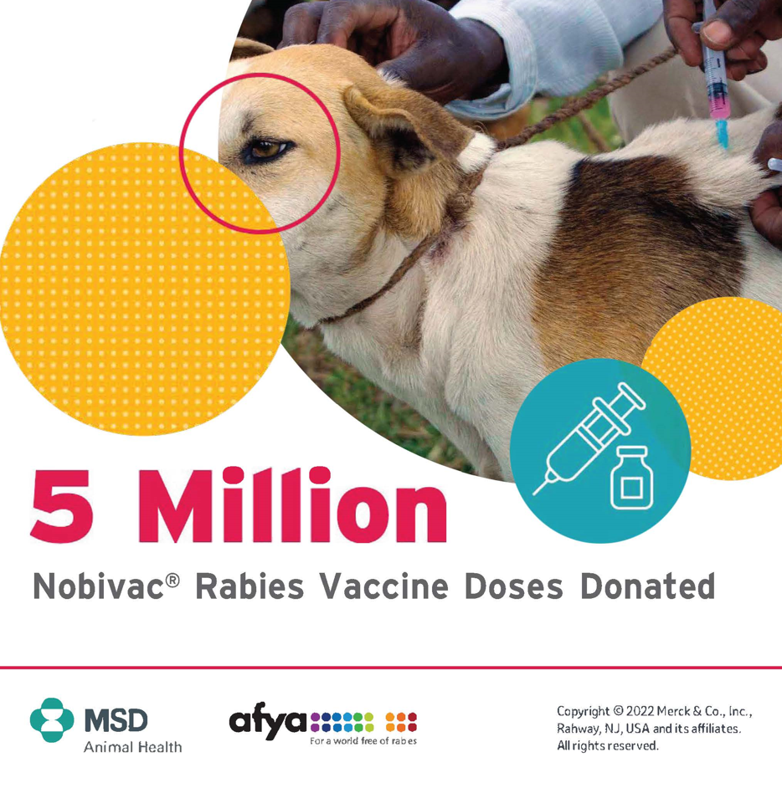
Post 7:  MSD Animal Health, through the Afya Program, has been donating canine rabies vaccines to their non-profit partners for vaccination campaigns for more than 25 years.  To date, 5 million doses of vaccines have been donated. Have your pet vaccinated with Nobivac® Rabies at our practice in support of this project.  Afya for a World Free of Rabies | The Afya Program  #EndRabiesNow  #Nobivac #BravectoSA #WorldRabiesDay | Post 7: Video  