Pet Diabetes Facebook posts

Post | Image
Post 1: Monday 2 November

This month is all about Sugar & Spike, and we’re not just talking about our cute friends, we’re talking about something that’s on the rise: Pet Diabetes. Diabetes mellitus is a common condition that affects the concentration of glucose, or sugar, in your pet’s blood. Diabetes occurs when your pet’s body makes too little insulin, stops producing it completely, or doesn’t utilise insulin properly which prevents the conversion of food to energy. The more you know, the faster you can respond and the sooner your dog or cat can start feeling better again.
Phone us today at {_____________________________} and schedule an appointment if you think your pet might have diabetes.

Post 2: Thursday 5 November
Sugar & Spike: The signs of Pet Diabetes!
Watch closely as Sugar points out the signs of Pet Diabetes.
There is help!
Phone us today at {_____________________________} and schedule an appointment if you think your pet might have diabetes.

Post 3: Monday 9 November  Some of the signs of Pet Diabetes are subtle at first. Is your pet eating more but not gaining weight? Increased thirst and urination are signs of Pet Diabetes. Talk to us if you think your pet might be showing these signs.  Phone us today at {_____________________________} and schedule an appointment if you think your pet might have diabetes. | 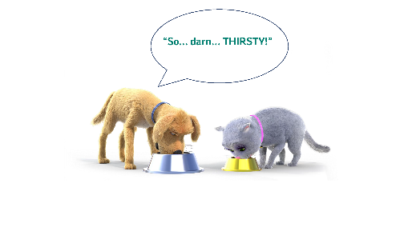
Post 4: Thursday 12 November

Watch as Sugar and Spike visit their Veterinarian!
Are you seeing any signs of Pet Diabetes in your furry friend? Phone us today at {______________________} and schedule an appointment if you think your pet might have diabetes.

Post 5: Monday 16 November  Middle age and older pets are at greater risk for Pet Diabetes. Obesity is also a risk factor for Pet Diabetes, especially in cats. A suitable diet and routine vet check-ups are key to keeping your pet healthy.  Phone us today at {_____________________________} and schedule an appointment if you think your pet might have diabetes. | 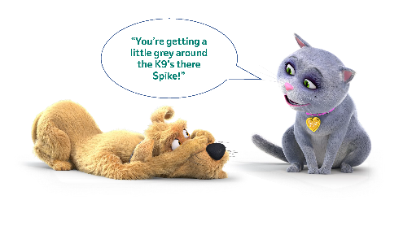
Post 6: Thursday 19 November  Manage your pet’s diabetes with the help of MSD Animal Health’s Pet Diabetes Tracker App! Download this free app today for Android or IOs:  Download the App from Google Play  Download the App from Apple Store  Visit www.msd-animal-health.co.za/pet-diabetes/ for more information on Pet Diabetes | 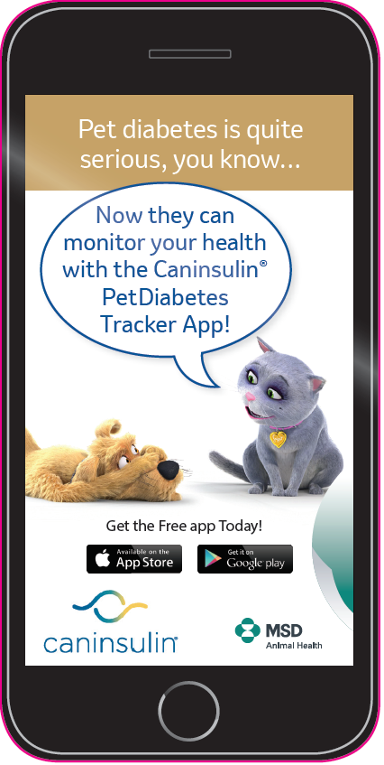
Post 7: Monday 23 November  Manage your pet’s diabetes with the help of MSD Animal Health’s Pet Diabetes Tracker App!  This app will help you:  Monitor and record your pet’s progress, create alerts and reminders and create and share records, charts and glucose curves with us!  Visit http://www.cat-dog-diabetes.com/ for more information. | 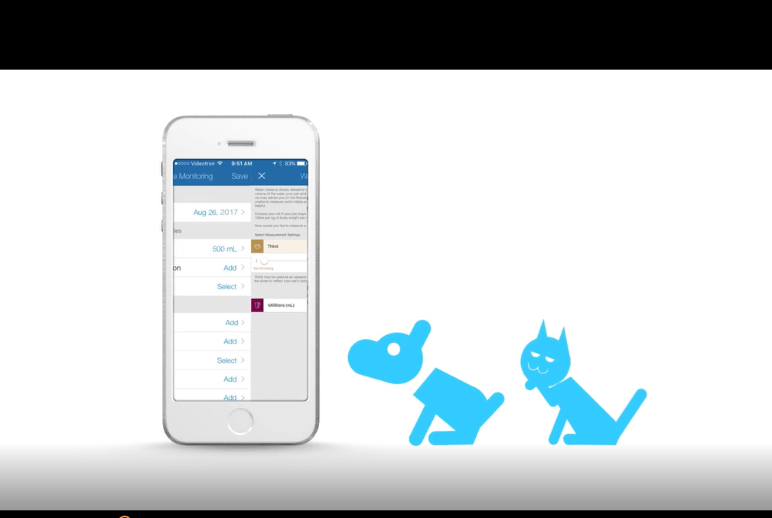
Post 8: Wednesday 25 November

It is our duty to make sure our pets are not only happy, but also healthy! If you see signs such as frequent urination, excessive thirst or a change in appetite, contact your veterinarian.

Phone us today at {_____________________________} and schedule an appointment if you think your pet might have diabetes.

Post 9: Friday 27 November

The story of Oscar!
Oscar was diagnosed with diabetes, but his diabetes is completely under control with the help of his veterinarian.
A healthy pet = a happy family.
Phone us today at {_____________________________} and schedule an appointment if you think your pet might have diabetes.

Post 10: Monday 30 November  Has your pet diagnosed with Pet Diabetes?  Be assured that you can monitor your pet much easier with the help of the FREE Pet Diabetes Tracker App and regular veterinarian visits.  Continually administer your pet’s insulin and give lots and lots of love! | 