POST CONTENT | IMAGE
Bravecto® Chew starts working within 2 hours and keeps protecting your dog or puppy against ticks, fleas and mites for 12 weeks. Now that’s extraordinary!  Contact us for more information or to order the Bravecto® that suits your pooch. | Post 1: 12 Week Protection  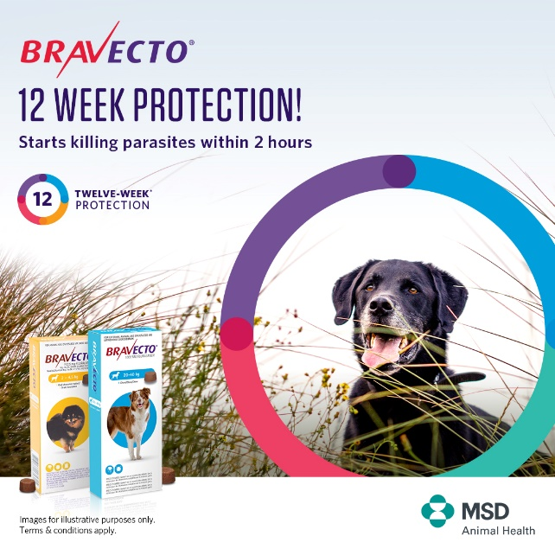
Did you know that ticks are dangerous and can carry diseases such as biliary? Biliary can be a fatal disease for your dog. Protect your best friend against ticks and fleas all year with just 4 doses of Bravecto®. 1 Tasty chew protects your pup against ticks, fleas and mites for 12 weeks!  Contact us to order or to find out more | Post 2: 4 Seasons  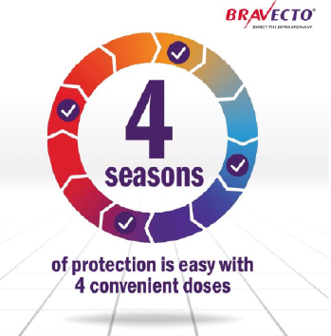
It feels like summer days are finally here and with lockdown level 1 we all want to get out and about, especially with our best friends! Keep your dog or puppy protected from nasty outdoor critters such as tick, fleas and mites with Bravecto®. Just 1 dose protects for 12 weeks, that is the whole of summer covered! And it won’t wash off either if your dog takes to the pool or sea to cool off.  Bravecto® is available at our practice, call us to order yours today or chat to us for more information. | Post 3: Summer  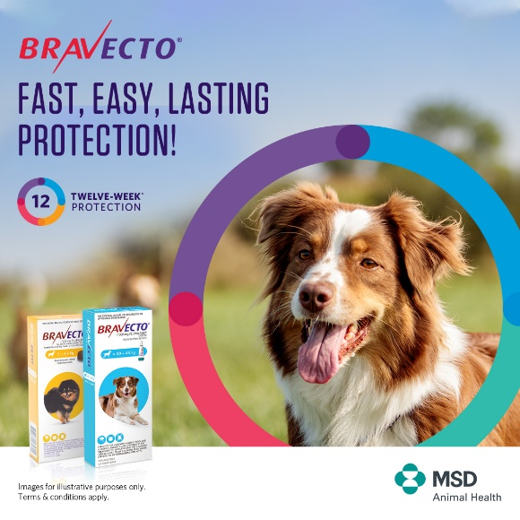
Would you like to take the worry out of protecting your pup against ticks, fleas and mites? Bravecto® gives your dog or puppy 12 weeks of worry free protection against ticks, fleas and mites in one tasty treat!  Bravecto® Chew is available at our practice, contact us today to place your order. | Post 4: Fast Easy Protection  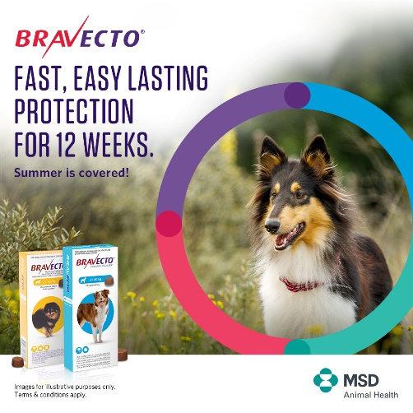
Only 5% of a flea population are on your dog, the other 95% can be found in your home in the form of pupae, larvae and eggs. Yuk! Break the flea lifecycle and rid your home of fleas by protecting your dog with Bravecto® Chew. One tasty treat protects dogs and puppies for 12 weeks against fleas, ticks and mites.  Let us help you get rid of that flea infestation, contact us today. | Post 5: Flea Lifecycle Pyramid  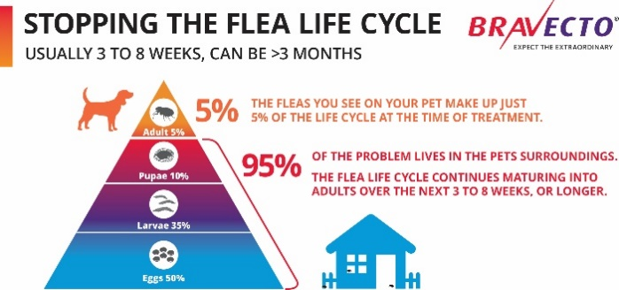
Did you know, a flea’s lifecycle can be up to 3 months long? Bravecto® Chew is the only tasty chew that covers the whole flea lifecycle in just 1 easy dose. Ask us about Bravecto® today. | Post 6: Flea Lifecycle Circles  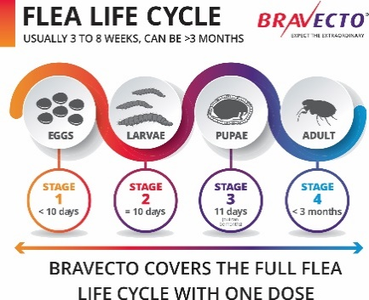
As a pet parent you want the best for your best friend. With Bravecto® you can provide just that: long-lasting parasite protection.  Bravecto® starts killing parasites within 2 hours and keeps going for 12 weeks. And it takes just one dose. | Post 7: Fast Protection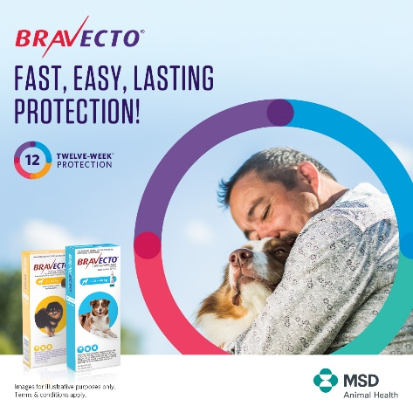
Its definitely feeling like summer! Unfortunately with summer comes an increase in ticks and fleas which is not such great news for your dog or puppy. Never fear, Bravecto® is here! Bravecto® Spot-on will keep your pooch protected from ticks for 4 months and fleas for 6 months! Get your dog or puppy protected so that you can both enjoy the warm weather outdoors worry free.  Ask us about Bravecto® today! | Post 8: One Dose  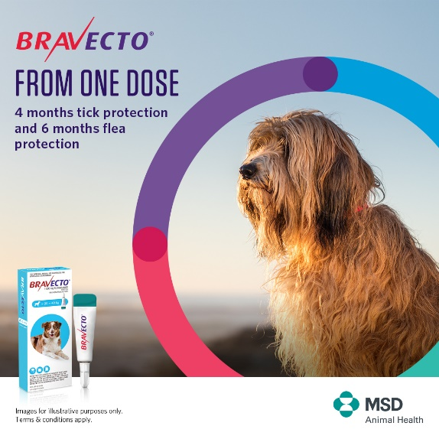
Does your dog just love to swim or play in the water? With Bravecto® Spot-On for dogs, you only have to wait 72 hours after applying before letting your dog swim or heading to the grooming parlour. Once it has been absorbed it works from the inside out so can’t wash off or be affected by swimming or shampooing. Get 4 months tick protection and 6 months flea protection in a single dose with Bravecto® Spot-On for dogs.  Call us today for more info or to place your order. | Post 9: Summer Water  