POST 1:

#Rabies is preventable, yet there are still an estimated 59,000 dog-mediated human deaths globally each year. Honour & support those saving #canine & human lives with #ForThemForUs. #MSDAnimalHealth @MissionRabies @RabiesFreeAfrica #WorldRabiesDay

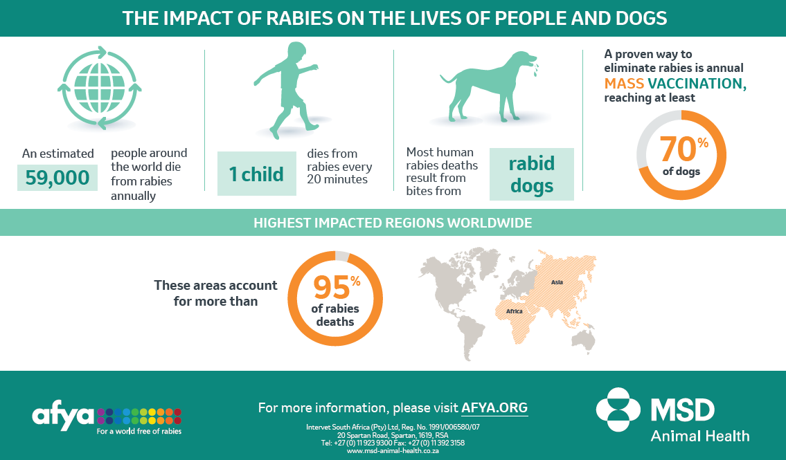

POST 2:

To prevent #rabies transmission, at least 70% of dogs in rabies-endemic areas need to be protected through annual mass-vaccination. Honour & support those saving #canine & human lives with #ForThemForUs. #MSDAnimalHealth @MissionRabies @RabiesFreeAfrica #WorldRabiesDay

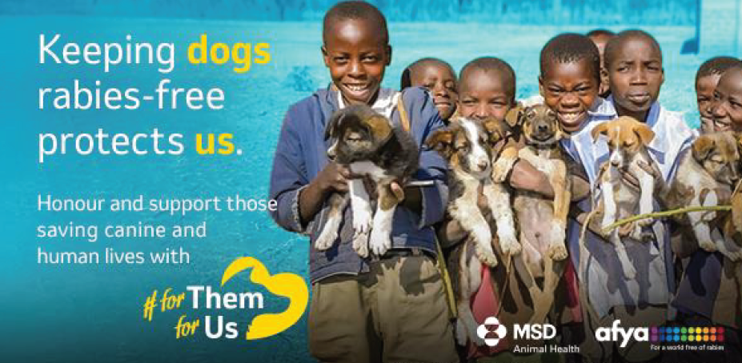

POST 3:

Someone around the world dies from #rabies every 9 minutes. Honour & support those saving #canine & human lives with #ForThemForUs. #MSDAnimalHealth @MissionRabies @RabiesFreeAfrica #WorldRabiesDay

VIDEO:
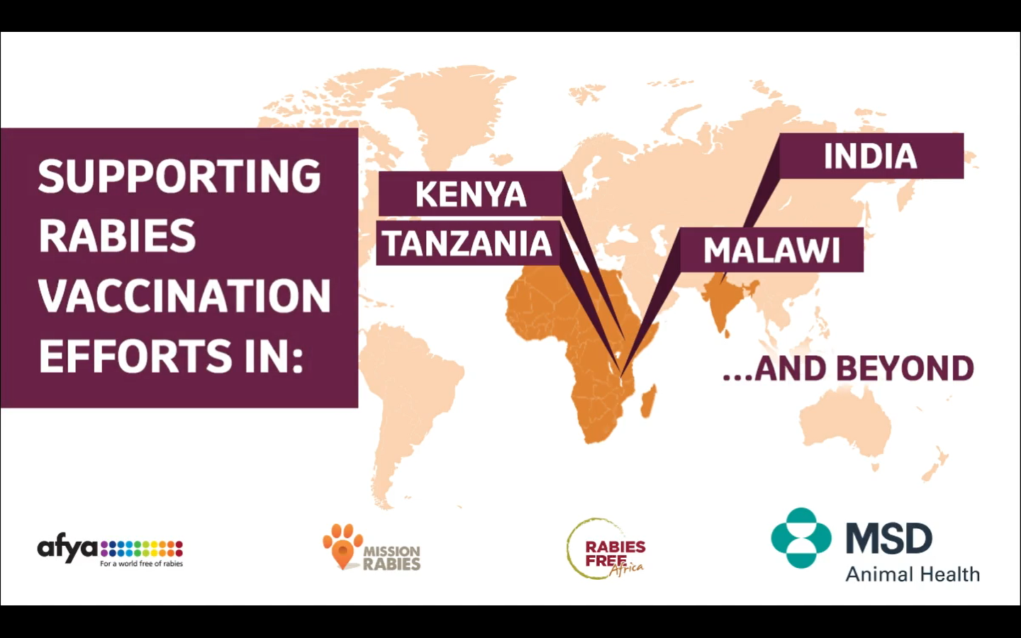

POST 4:

Rabies is still a very real health concern. More than 20 000 children, aged 15 years & younger die of #rabies each year. Honour & support those saving #canine & human lives with #ForThemForUs. #MSDAnimalHealth @MissionRabies @RabiesFreeAfrica #WorldRabiesDay

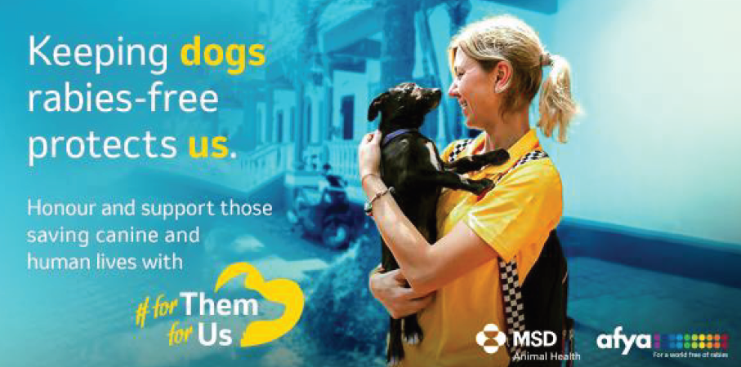
POST 5:

There are an estimated 900 million dogs around the world, but majority are not household pets. Honour & support those saving #canine & human lives with #ForThemForUs. #MSDAnimalHealth @MissionRabies @RabiesFreeAfrica #WorldRabiesDay

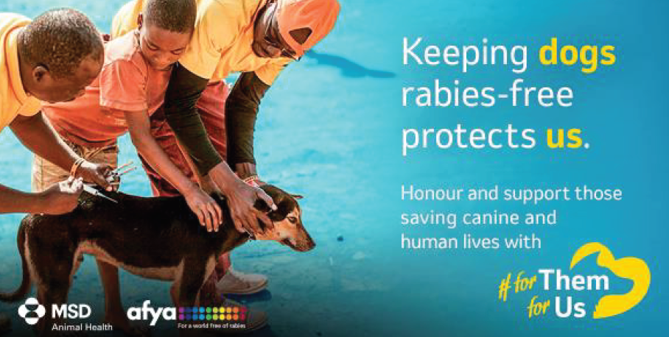
POST 6:

#Veterinarians & volunteers provide critical #rabies vaccination efforts. Honour & support those saving #canine & human lives with #ForThemForUs. Do you know one of these heroes? Share pics and pay tribute in the comments below. #MSDAnimalHealth @MissionRabies @RabiesFreeAfrica #WorldRabiesDay

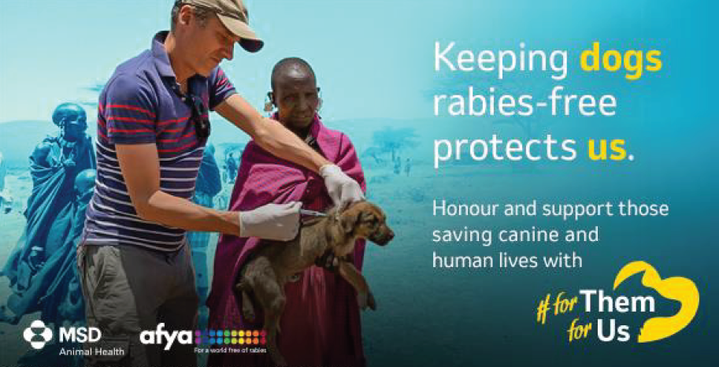
POST 7:

11,000 km² is now a #rabies free zone in Serengeti, Tanzania thanks to the @RabiesFreeAfrica team! Ensure that you are doing your part in keeping your area rabies free and get your pet vaccinated today! Contact us for more information.
#ForThemForUs #WorldRabiesDay

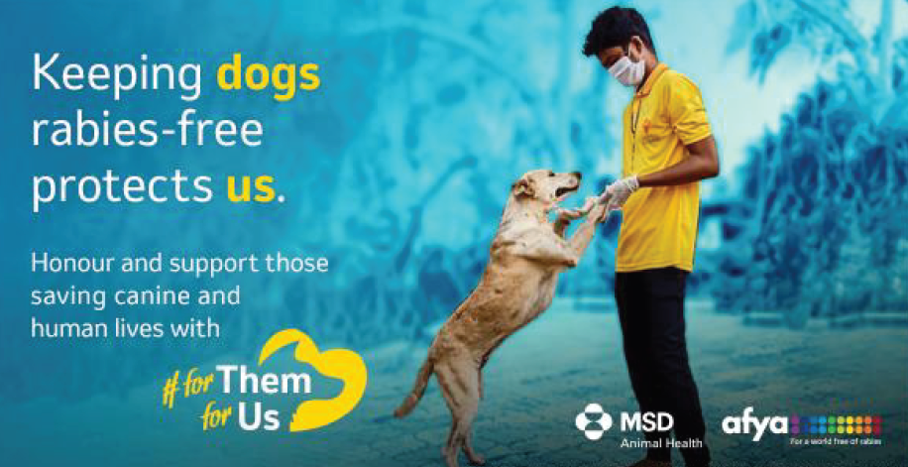
POST 8:

Goa, India has had ZERO human #rabies cases in the past two years thanks to @MissionRabies veterinarians & volunteers! #ForThemForUs #WorldRabiesDay

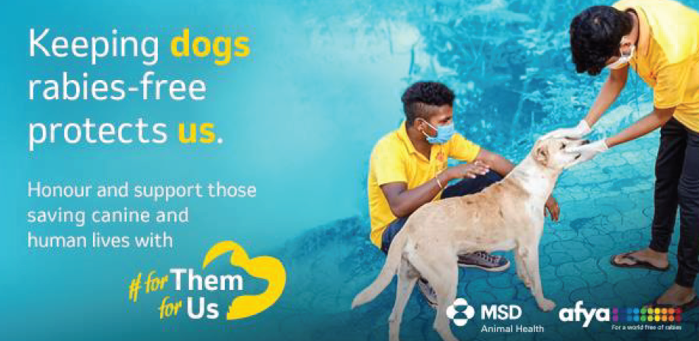
POST 9:

Over 3 MILLION doses of #rabies vaccine have been donated through the #AfyaProgram to help meet the @WHO Zero by 2030 goal! You can also make a difference! Contact us about vaccinating your pet with Nobivac® today. For all Nobivac® vaccines we administer, MSD Animal Health donates rabies vaccines to organisations through the Afya Project to help efforts in India, Africa and Asia. #MSDAnimalHealth = #ForThemForUs

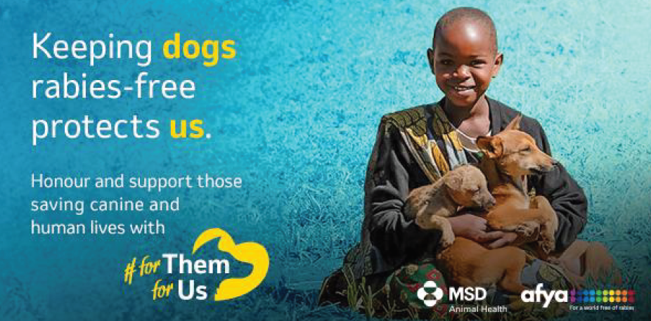
POST 10:

Collaboration & #vaccination can eliminate #rabies. Honour & support those saving canine & human lives with #ForThemForUs. #MSDAnimalHealth @MissionRabies @RabiesFreeAfrica #WorldRabiesDay
VIDEO:
POST 11:
No matter where you live, your support continues to reach those across the globe, one dose at a time. We are making a difference, together. #ForThemForUs #MSDAnimalHealth @MissionRabies @RabiesFreeAfrica #WorldRabiesDay
Afya.org VIDEO:

