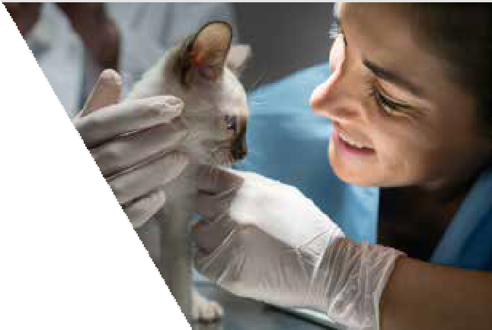Subject Line: When you’re ready, let’s come together for your pets
Neighborhood Vet Clinic
###-###-####
WHEN THE TIME IS RIGHT,
PLEASE CONTACT US:

FOR PETS

The love of pets first brought us together. Now, the health of pets motivates us to come together even more.
If you need advice, we’re here to help. Let’s reconnect when you’re ready and continue to care for pets like only we can—together.

Intervet South Africa (Pty) Ltd | Reg.No 1991/006580/07
20 Spartan Road, Spartan, 1619, RSA | Private Bag X2026, Isando, 1600, RSA Tel: +27 (0)11 923 9300 | Fax: +27 (0)11 392 3158 | Sales Fax: 086 603 1777 www.msd-animal-health.co.za

