Content Calendar
Below please find content and images ready for you to use on your practice social media pages. The text can be copied and pasted from the column on the left and edited as you wish to personalise for your practice. The name below each image/video on the right is the name of the asset that can be downloaded from https://www.msd-animal-health.co.za/social-media-repository/
Post | Image
Post 1:  In these uncertain times it is important for us to come together, for ourselves and for our pets. In a socially distant way of course Lets be sure to come together to ensure your pet’s good health. Don’t forget to book that annual health check up and vaccination with us.  Contact us on *insert practice telephone number* to book your appointment today  #ComeTogether | Video:  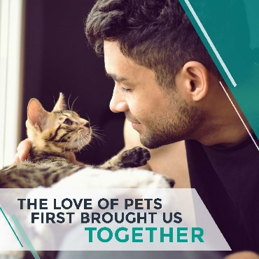  Post 1 Come Together Video
Post 2:  A warm cosy winter home provides the perfect environment for fleas to develop, as eggs that were laid in summer and autumn can continue to develop through winter. One Bravecto® treatment covers the full flea lifecycle. Ask us about Bravecto® for your dog or cat today.  #Bravecto #FleaFreePets | Video:  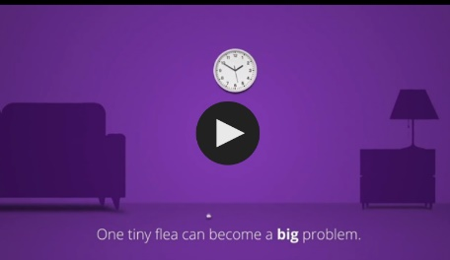  Post 2 Flea Lifecycle Video
Post 3:  If you have fallen behind on your pet’s vaccinations, deworming or parasite control, not to worry, we are here to help! Contact our friendly reception staff on *insert practice telephone number* to discuss your needs or to book an appointment.  #ComeTogether | 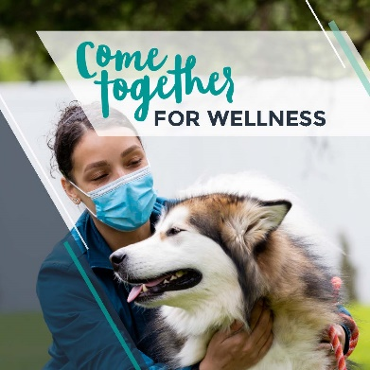  Image  Post 3 Image Wellness
Post 4:  Did you know? Feline Leukaemia Virus (FeLV) is a viral disease specifically found in cats that can cause serious and potentially fatal health conditions by supressing your cat’s immune system. Younger cats and kittens are even more at risk for contracting the virus. The only way to protect your kitty is through vaccination, contact us today on *insert practice phone number* to book an appointment or to find out more.  #Nobivac’d | 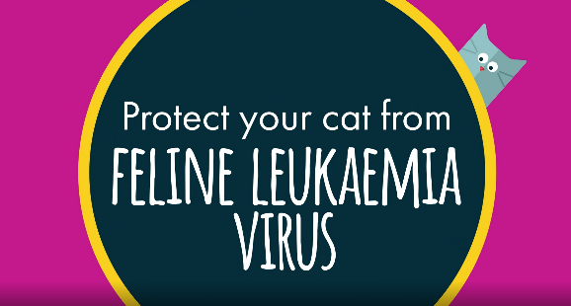  Video  Post 4 Felv Video
Post 5:  Did you know? Sarcoptes mites cause scabies mange. It is a highly contagious disease, therefore it is important to protect all dogs in your household. A single dose of Bravecto® Chew or Bravecto® Spot-On for dogs eliminates these mites! Ask us about Bravecto® for your dog or puppy today.  #Bravecto | Video  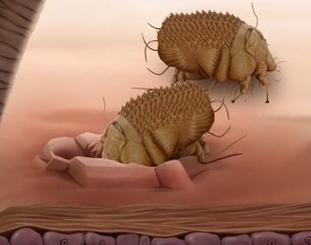  Post 5 Sarcoptes Video
Post 6:  One of the best things you can do to give your dog a long and healthy life is to ensure that he or she is vaccinated against common diseases. Your pet should be protected against those diseases which are most common, highly contagious and which cause serious  illness. These diseases include Canine Distemper, Canine Parvovirus, Canine Hepatitis, Kennel Cough and Rabies. Speak to us about the vaccination protocol that suits your pet.  #Nobivac’d #Vaccinate | 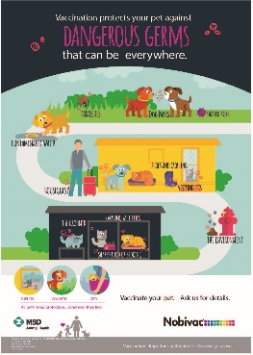  Image  Post 6 Dangerous Germs Image
Post 7:  Life is busy, we know. So many things to juggle and remember. Let us help you make one thing easy and convenient – protecting your cat or dog against ticks, fleas and mites. Bravecto® provides at least 12 weeks of uninterrupted protection with just 1 dose. Contact us today to get your pets the Bravecto® protect that suits them. | Image  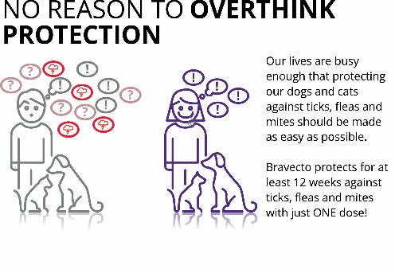  Post 7 Dont Overthink Protection
Also available for you to use as a slide show for your practice screen encouraging your in-clinic pet owners to consider other health aspects for their pet, and to discuss this in their consult. Click here to visit the page, scroll to the end to locate the In Clinic Slide Show and download

